**DATABASE Project**



**Submitted by:**

*Farhan Munir*

*Muhammad Rehan Siddique*

Roll No: 232396

232523

BSCSev-II-C

**Submitted to:**

*Ma’am Kainat Nazir*

Dated: 19/05/2024

AIR UNIVERSITY , ISLAMABAD

**Introduction:**

Overview of the project: The project is aimed at developing a gaming store database system to manage various aspects of the store's operations.

Objectives and goals: The main objective of the project is to create a comprehensive and efficient database system that can handle inventory management, sales tracking, customer information, and other relevant data for the gaming store.

Significance of the project: The gaming store database system will provide numerous benefits, including improved inventory management, enhanced customer service.

***Requirements Gathering:***

Identify the purpose and objectives of the gaming PC store database.

Determine the key functionalities required, such as inventory management, customer management, order tracking, etc.

Gather information about the types of data to be stored, such as product details, customer information, sales data, etc.

Identify any specific business rules or constraints that should be considered.

***Use Case Diagrams:***

Create a use case diagram to visualize the interactions between users and the database.

Identify the main users involved, such as store employees, customers, stores and products.

Define the main use cases, such as adding products, updating inventory, etc.

Identify any additional use cases for system maintenance.

***Functional and Non-functional Requirements:***

Define the functional requirements, which describe the specific features and functionalities of the system, such as:

* Ability to add, update, and delete products in the inventory.
* Ability to track customer orders and generate invoices.

System Design

* Entity-Relationship Diagram (ERD)

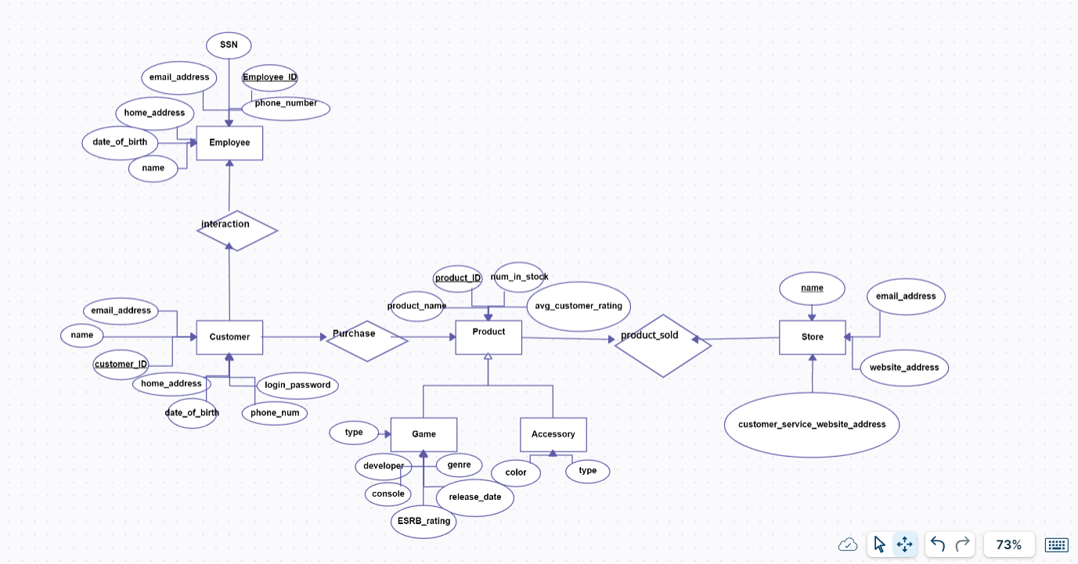

4. Database Design

Schema design.

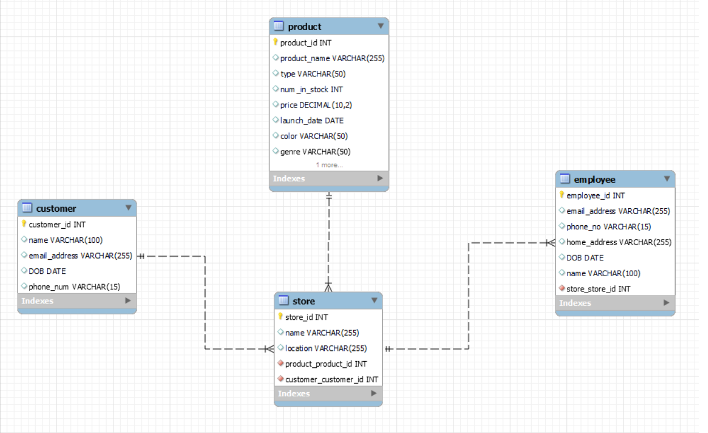

• Table definitions and relationships.

Table 1: Products

* Primary key: Product_id
* Attributes:
* Product_name
* Type
* Num_in_stock
* Price
* Launch Date
* Color
* genre
* Table 2: Customer
* Primary key: Customer_id
* Attributes:
* Name
* Email_address
* DOB
* Phone_num

Table 3: Employees

* Primary key: Employee_id
* Attributes:
* Email_Address
* Phone_no
* Home_address
* DOB
* Name
* store

Table 4: Store

* Primary key: Store _id
* Attributes:
* Name
* Location
* Product_id
* Customer_id

Normalization process.

ALL the tables are normalized in a form that is easy to understand and better for analyzing the given data.

SQL queries for data manipulation.

* All kinds of manipulations are handled through front-end on MS ACCESS

5.Implementation:

Code structure.

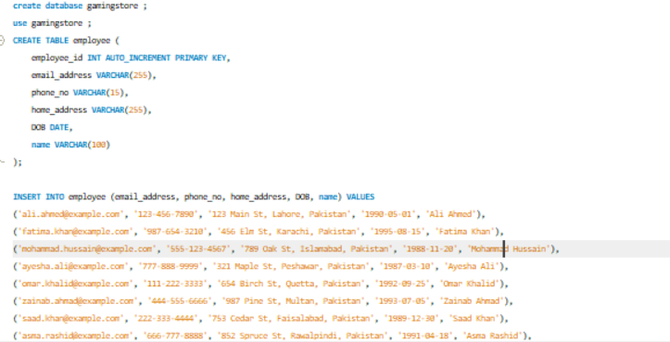

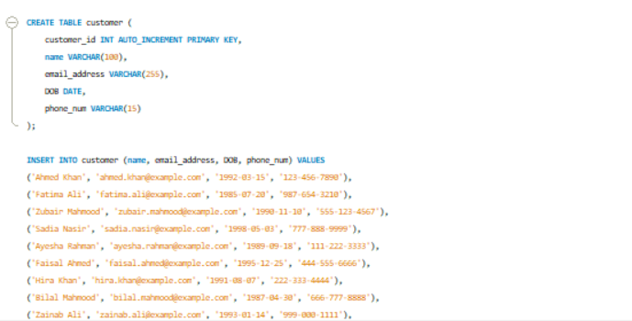

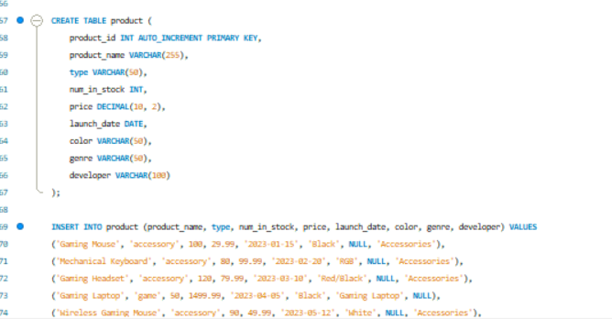

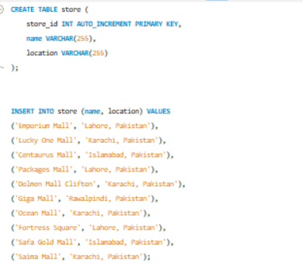

* Modules and functions

No functions are used.

* Integration of different components.

The Database is created on MYSQL and the front-end is built on MS ACCESS.

The database is integrated using ODBC software that enabled us to easily connect the database.

6. User Manual

* Step-by-step instructions for using the system.

1. Open the front-end using MS ACCESS
2. Now open the forms
3. At last, add a new record using button



4.Or if you want to update a record then first select it using buttons and then simply edit the changes and click on 

button

5.Now, you have successfully make the changes and added a new record

6. To delete a record select the record using button and then click on

Delete button

* Screenshots of the interface.
* 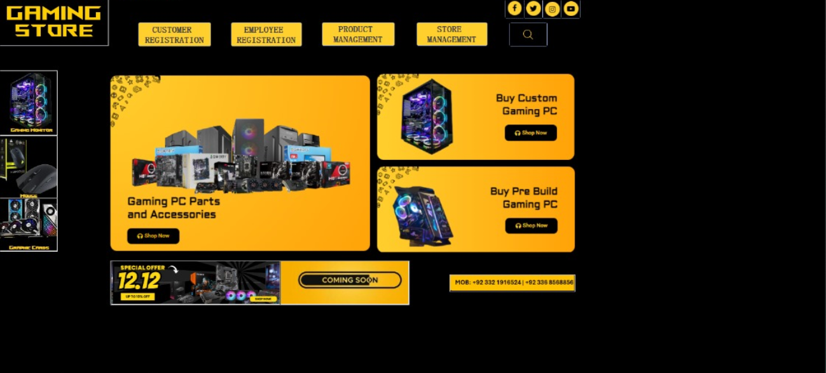

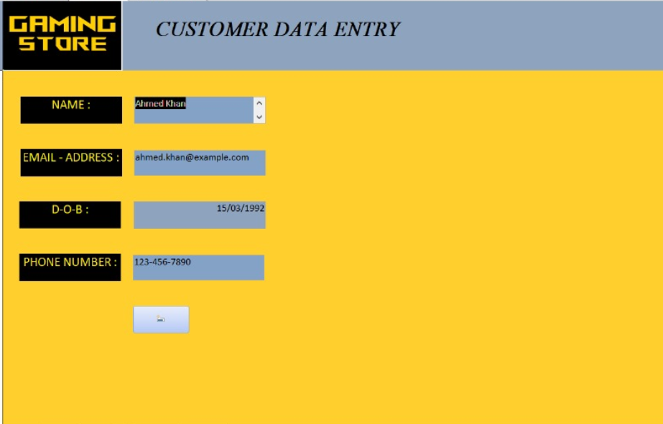





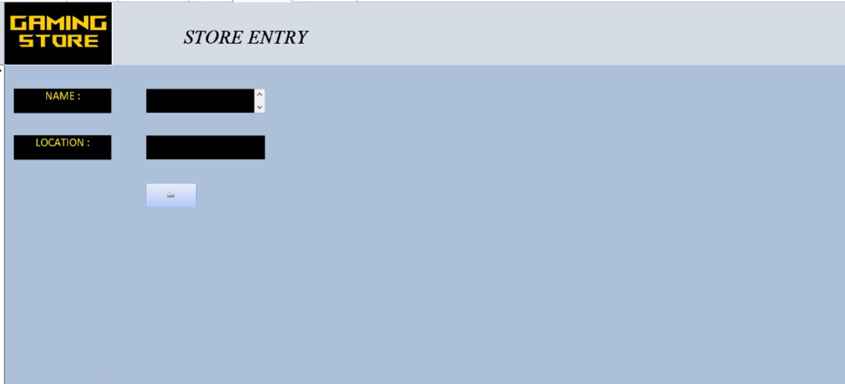

* Common troubleshooting tips.

Till now we have faced zero problems but if the front-end disconnects then just simply

Try reconnecting the database using ODBC in simple two-steps.

**Summary of the Project**

The gaming PC store database project aimed to design and implement a detailed database system to manage the various aspects of a gaming PC retail business. The project involved creating a database on MYSQL that could efficiently handle data related to inventory, customer information, employee records and store. The system was built to ensure data integrity, and immediate effect for better understanding of this business. Key features included stock-info, customers date, and products sales count for higher sales target reaching.

**LIMITATIONS:**

High-Scalability: The current database design might face performance issues as the data volume grows, particularly if the business expands significantly.

User Interface: The project primarily focused on the backend database, with a basic user interface. A more user-friendly and feature-rich interface could enhance usability.

**Potential Enhancements and Future Improvements**

To address these limitations and further improve the database system, the following enhancements and future improvements are recommended:

* Database Optimization and Scalability:

Implement database sharing and other strategies to improve performance.

Explore cloud-based database solutions to ensure scalability and reliability.

* Advanced User Interface:

Develop a more intuitive and interactive user interface using modern web technologies.

Include features like customizable dashboards, and mobile accessibility.

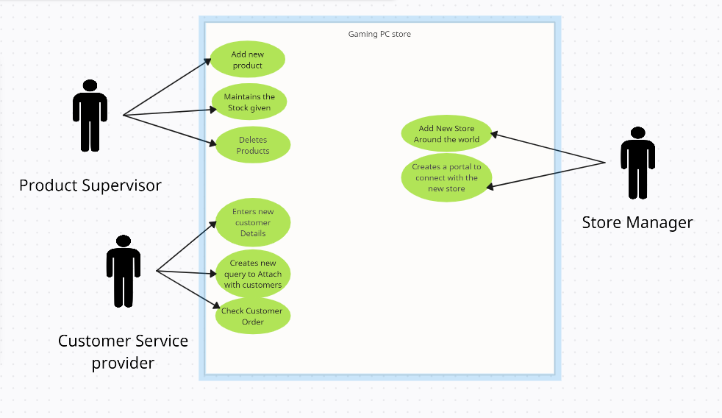User Case Diagram: